SSD

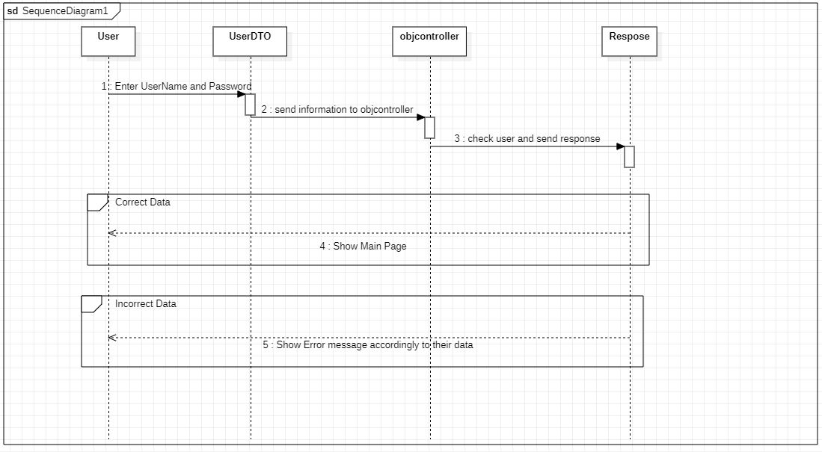

### Arsal Bilal (SP21-BSE-040)

#### Use Case: login

|  |  |
| --- | --- |
| Use case name | Login |
| Scope | Contextual chatting app |
| Level | User goal |
| Primary actor | User |
| Stakeholder and interest | * Admin: When user entered their email and password admin check if his/her information is in the server than it will proceed to the main menu of the app. * Users: User after login chat with contacts and the groups of their interest |
| Precondition | The user must have stable internet connection. |
| Success guarantee (post condition) | After login user can chat into the App and see the news feed of their interest and read the information about their field of interest. |
| Main success scenario | 1. The admin will have notice when a new user login with the app 2. The groups will get another individual to discuss matters of certain concern. 3. The user if satisfied by the app will promote the app and more users will enter the app. |
| Exception | * User could not login due to server issues. * User could not get login if he has some connection issue * User could not get the login if the user enter the wrong information or cant fill all the necessary text fields or password fields |
| Special requirement | At the time of login, the user must have stable internet and the username and password will be same as the time of registration else user will not succeed to the app dashboard. |
| Technology and data variation list | The app is only available in operating system, so user have the operating system. Operating system version is greater than version 7, than this app will work properly. |
| Frequency of occurrence |  |

Operation Contract

|  |  |
| --- | --- |
| **Contract SP21-BSE-040: Login** | |
| **Operation:** | Clicked on Login Button. |
| **Cross References:** | Use case: Login. |
| **Pre-conditions:** | * The user must have stable internet connection. |
| **Post-conditions:** | * Login to the system successfully. |